Classroom Tips for Teachers

Cognitive:  Concentrate first on general cognitive skills, such as flexible thinking and organization, rather than academic content.  Focus on what the student does well and expand the curriculum to more challenging content as concussion symptoms subside.  Adjust the student’s schedule as needed to avoid fatigue: shorten day, time most challenging classes with time when the student is most alert, allow for rest breaks, reduce course load  Adjust the learning environment to reduce identified distractions or protect the student from irritations such as bright light or loud noises.  Use self-paced, computer-assisted, or audio learning systems for the student having reading comprehension problems. | Allow extra time for test/in-class assignment completion.  Help the student create a list of tasks and/or daily organizer.  Assign a peer to take notes for the student. Allow the student to record classes.  Increase repetition in assignments to reinforce learning.  Break assignments down into smaller sections and offer recognition cues.  Provide alternate methods for the student to demonstrate mastery, such as multiple-choice or allowing for spoken responses to questions rather than long essay responses.
Emotional:  If the student is frustrated with failure in one area, redirect him/her to other elements of the curriculum associated with success.  Provide reinforcement for positive behavior as well as for academic achievements.  Acknowledge and empathize with the student’s sense of frustration, anger or emotional outburst. “I know it must be hard dealing with some things right now.”  Provide structure and consistency, make sure all teachers are using the same strategies.  Remove a student from a problem situation, but avoid characterizing it as a punishment and keep it as brief as possible. | Establish a cooperative relationship with the student, engaging him/her in any decisions regarding schedule changes to task priority setting.  Involve the family in any behavior management plan.  Seat reasonable expectations.  Arrange preferential seating, such as moving the student away from the window (bright light), away from talkative peers or closer to the teacher.  Source: CDC-Heads Up to Schools: Know Your Concussion ABC’s

There should be ongoing communication with the parent and nurse/HOA regarding the student’s concussion, so they are aware of symptoms that occur during the school day.

CMT-1 (Concussion Report for Students and Visitors)

Name: |  | School/Facility:
Address: |  | DOB:
Date of Injury: | Time of Injury: |  | [ ] Male [ ] Female
[ ] Student [ ] Visitor | Parent Name: |  | Phone #

- ACTION TAKEN (check all that apply):

First Aid Administered. By whom _______________________________ _________________________ Parent Notified

Unable to contact parent

Remained in or returned to class
Sent home. Released to
911 called
Taken to ER. By whom:
No action taken.
OTHER:

- NATURE OF INJURY:

Loss of Consciousness Concussion (suspected)

DESCRIPTION OF EVENT CAUSING INJURY:

PLACE OF INJURY:

Classroom

Hall

Library

Cafeteria

Gym

Other

Previous Medical History:

Signature of Person Completing Form Date/Time

CMT-2 (Student Symptom Monitoring Tool)

Student Date Week #

The school nurse/HOA will meet with the student daily for the first two weeks after returning to school. The nurse/HOA will rate each symptom that the student is currently experiencing that were not present prior to the concussion.

Severity Rating: 0=NONE 1=MILD 2=MODERATE 3=SEVERE
Rate Symptom Severity | DATE | DATE | DATE | DATE | DATE | DATE
 | TIME | TIME | TIME | TIME | TIME | TIME
Headache
Nausea
Balance Problems
Dizziness (spinning or movement sensation)
Lightheadedness
Fatigue, drowsiness. Tired
Blurry or double vision
Sensitivity to light
Sensitivity to noise
Numbness or tingling
Feeling slowed down, groggy, sluggish or having no energy
Feeling like “in a fog” or foggy
Difficulty concentrating
Difficulty remembering
Sad or depressed
Nervous or anxious
Feeling more emotional
Irritable
Trouble falling asleep (at home)
Sleeping more (at home)
Sleeping less (at home)
Total # of symptoms

CMT-3 (Teacher Notification of Student Concussion)

Name: | DATE:

This student has sustained a concussion. The best treatment for a concussion is cognitive and physical rest. The student should be provided academic adjustments while at school to ensure the student is learning and to prevent symptoms from increasing in severity, which could delay recovery. The following adjustments are needed at this time:

Adjustments for Concussed Students:
- Reduce all in-class work by 50% (reduce work and require only critical content, cut all repetition once mastery is demonstrated).
- Schedule rest breaks built into the day (5-10 minutes every 30-45 minutes in a quiet place as tolerated (head down, library, study hall, clinic) OR incorporate 15-20 minute rest period midmorning and mid- afternoon. Adjust if having student experiencing symptoms.
- Initially excuse from tests, quizzes, standardized tests or homework
- Provide the student with copies of notes (teacher or peer generated)
- Temporarily excuse from classes/activities that may be over stimulating due to light and noise (choir, band, lunchroom, computers, whiteboards, behind the wheel driver’s training, shop, etc.)
- Excuse from physical activity (PE, recess, sports, etc.) after cleared by physician or symptom free, (7) days or no PE, then (7) days of no contact activities with gradual progression.

If the student experienced a period of time at home following a concussion, all missed assignments should be reviewed to determine what can be excused and not excused.

We will be monitoring, adjusting and reducing adjustments over time as the student recovers based on your feedback. Please contact us if your school’s nurse or HOA OR the School Nurse Coordinator at 276-634-4753.

Thank you,

School Nurse/HOA _______
School Nurse Coordinator ______

CMT-4 (Student Concussion Monitoring Tool)

The Concussion Management Team would like you to complete this form in order to monitor student concussion symptoms in the classroom.

Name: | DATE:

Place an X next to any behaviors this student displayed this past week that were not observed PRIOR to
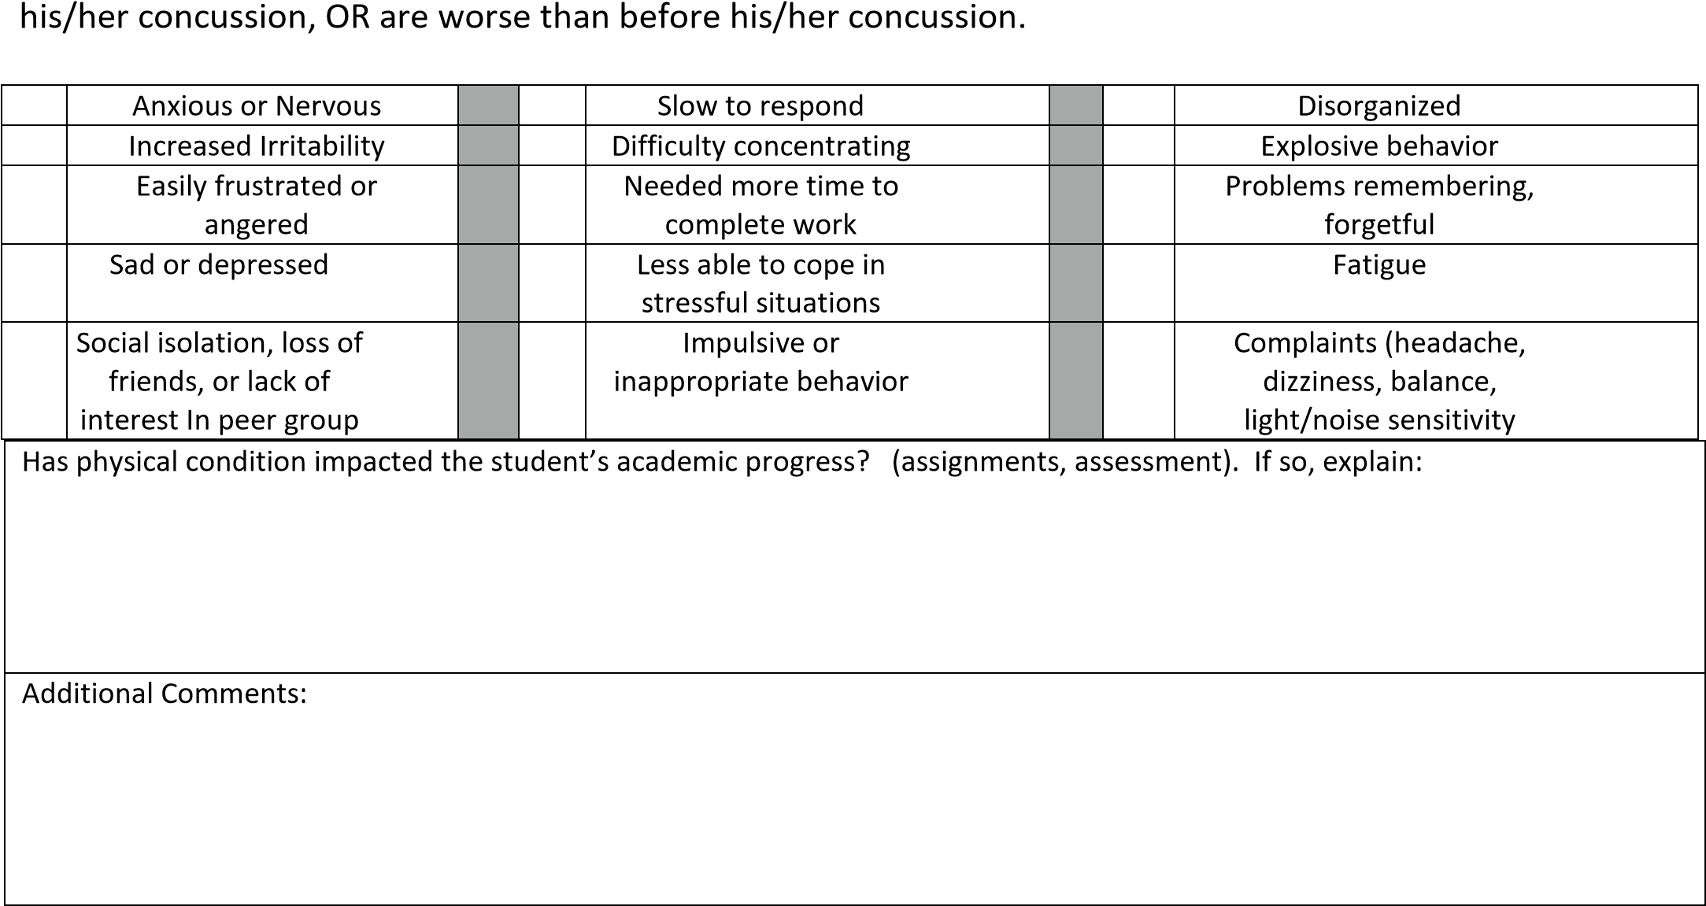
Please return to Academic Monitor with copy to school nurse/HOA.

CMT-5 (Recommendations to Address On-Going Symptoms)

Name: | DATE:

Physical |  | Thinking and Cognitive |  | General and Emotional
 | Reduce all homework, class work and projects by 50% |  | Temporarily excuse from:  -Homework  -Projects  -In class assignments  -Tests and quizzes  -Standardized tests |  | Temporarily excuse from classes or activities that may be over stimulating due to light or noise
 | Avoid hallways during crowded times. Leave class early |  | One test or quiz per day. Increase over time as tolerated. |  | Schedule rest breaks (510) minutes every 30-45 minutes OR, incorporate 15-20 minute rest periods mid-morning and mid-afternoon.
 | Have a peer carry student’s books in hallway |  | Testing in a quiet room |  | Allow rest periods
 | Allow headphones/ear  buds to block noise |  | Open notes or notebook tests |  | Allow participation in low stress activities
 | Provide student with prior notice of fire drills, tornado drills, etc. |  | No note taking. Provide copies of teacher or peer generated notes. |  | Develop an emotional support plan with the student
 | Allow use of ball cap or sunglasses indoors to shield light |  | Provide alternatives to written output for tests, quizzes, homework and projects.  Allow oral answers. |  | Lunch in a quiet place
 | Other: |  | Provide word banks, multiple choice, notecards |  | All missed assignments should be reviewed to determine what can be excused
 | Other |  | Other |  | Other

CMT-6 (Return to Play Monitoring Tool)

Name: | DATE: | Week #

Rehabilitation Stage | Functional Exercise at Each Stage | Objective of each Stage | Date  Completed
No Activity | Physical and Cognitive Rest | Recovery
Light Aerobic Exercise | Walking, swimming, or stationary cycling keeping intensity, 70% maximum of predicted heart rate. No resistance training. | Increase heart rate
Sport-Specific Exercise | Running drills in football/basketball or running drills in soccer. No head impact activities | Add movement
Non-Contact Training Drills | Progression to more complex training drills, eg. Passing drills in football and basketball. May start progressive resistance training. | Exercise, coordination, and cognitive load.
Full Contact  Practice | Following medical clearance participation in normal  training activities | Restore confidence and assess functional skills by coaching staff
Return to Play | Normal game play

***Student must have a physician’s note attached releasing student to return to play.

